**DatBase Operations**

**Firstly I created the Database and the Table.**

**CREATE TABLE Transactn (id INT NOT NULL AUTO_INCREMENT PRIMARY KEY, name VARCHAR(20), amount VARCHAR(20), date_created datetime);**

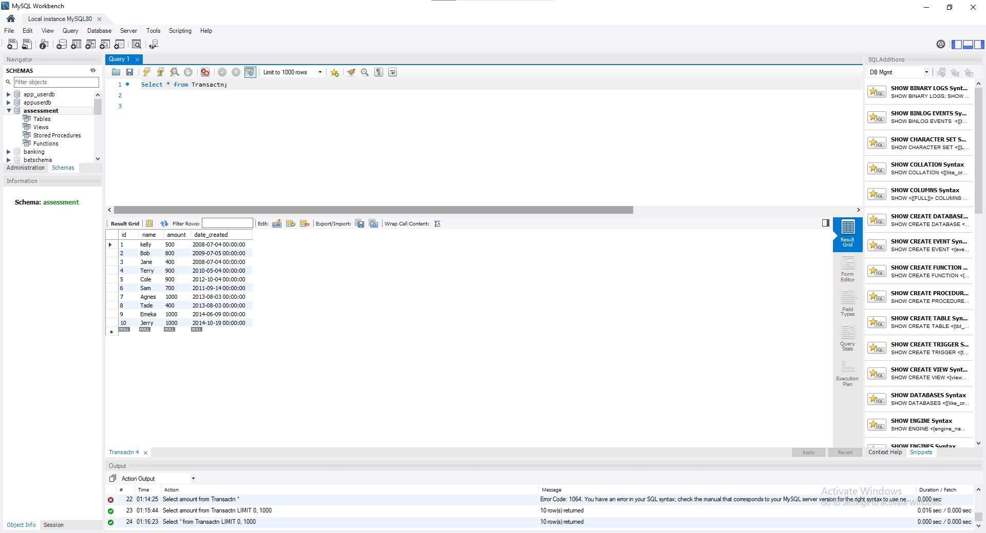

**group by year**

**Select extract(year from date_created) as year,**

**sum(amount)As Total_amount from Transactn group by extract(year from date_created);**

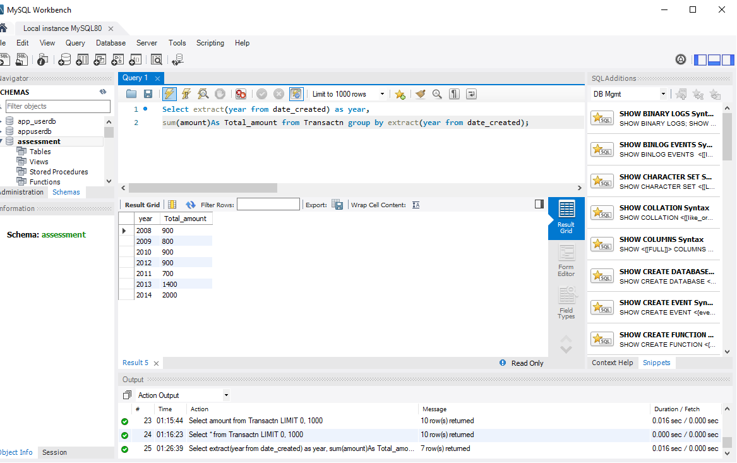

**group by month**

**Select extract(month from date_created) as year,**

**sum(amount)As Total_amount from Transactn group by extract(month from date_created);**

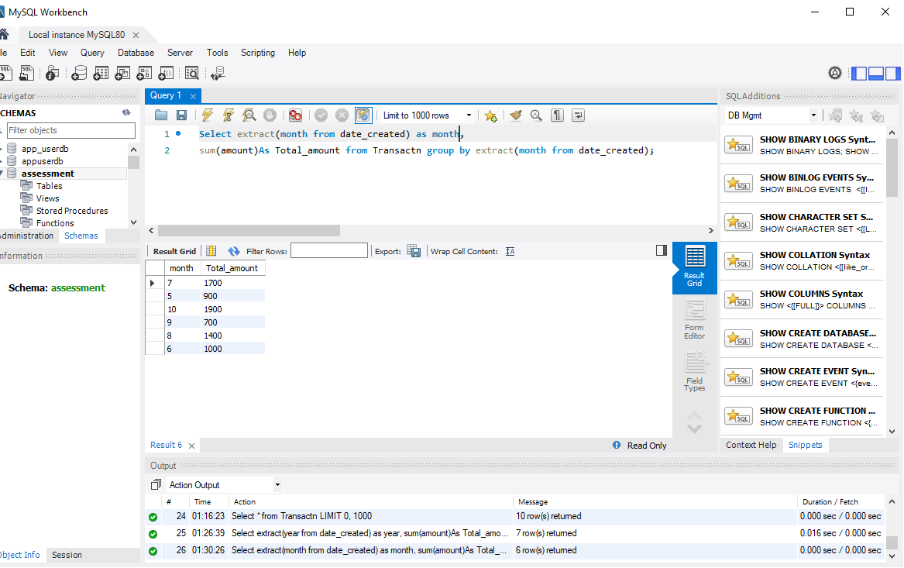

**group by name**

**select name,**

**sum(amount) as total_amount from Transactn group by name;**

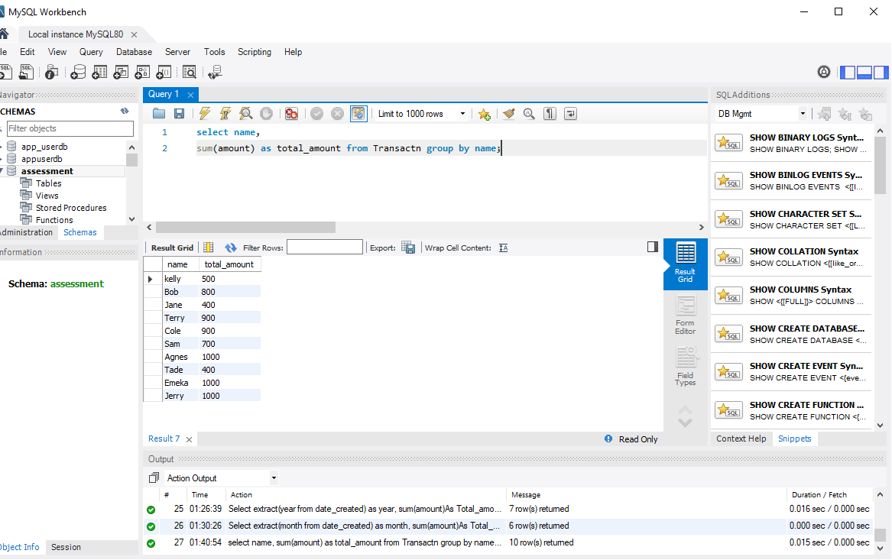

**What do you understand by Micro-services?**

It is structural way of designing or building a software into a smaller services that communicate via a design APIs. It enables loose coupling, scalability and ease of maintenance.

**What do You Think about testing?**

Testing is a defensive programming where all software requirement are tested and verified to do what it’s designed to do. There is TDD, development testing etc.